Blinkit Analysis
1.See all the data imported
SELECT * FROM blinkit_data

2. DATA CLEANING:
Cleaning the Item_Fat_Content field ensures data consistency and accuracy in analysis. The presence of multiple variations of the same category (e.g., LF, low fat vs. Low Fat) can cause issues in reporting, aggregations, and filtering. By standardizing these values, we improve data quality, making it easier to generate insights and maintain uniformity in our datasets.
UPDATE blinkit_data
SET Item_Fat_Content =
CASE
WHEN Item_Fat_Content IN ('LF', 'low fat') THEN 'Low Fat'
WHEN Item_Fat_Content = 'reg' THEN 'Regular'
ELSE Item_Fat_Content
END;

(Personal Note:
UPDATE table_name- used to update the data without having to delete anything.
SET coloumn_name - identify which coloumn you want to update
CASE statements and WHEN/THEN-used like if/else, WHEN there is some data THEN what should be the ouput
IN – used when you wanna change multiple values. In the example LF,low fat both needs to be changed to ‘Low Fat’. Use = when there is a single value than needs to be changed.)

After executing this query check the data has been cleaned or not using below query
SELECT DISTINCT Item_Fat_Content FROM blinkit_data;
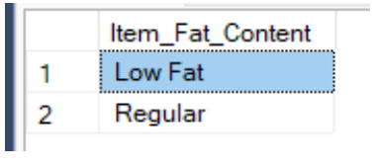
KPI’S
- Total Sales

SELECT CONCAT(CAST(SUM(Total_Sales)/1000000.0 AS DECIMAL(10,2)), ’ M’) AS Total_Sales_Million
FROM blinkit_data;

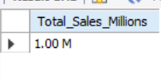

(Personal Note:
SUM(coloumn_name)- gives the sum of the required

CAST(expression AS target_data_type) - used to convert a value of one data type into another data type.

-we divided total sales/10^6 to get the output in millions
DECIMAL(10,2)- This means if there are 10 digits after decimal show only 2 after decimal)

CONCAT(string1,string2….)- It combines the two )

- Average Sales
SELECT ROUND(AVG(Sales), 0) AS Average_Sales FROM blinkit_data;
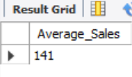
(Note-
ROUND(expression,length) - used to round a numeric value to a specified number of decimal places or precision. )
- No. of Items
SELECT COUNT(*) AS No_of_Items FROM blinkit_data;
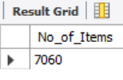
- Average Rating
SELECT ROUND(AVG(Rating),0) AS Average_Rating FROM blinkit_data;
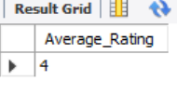

SELECT `Item Fat Content`,
cast(SUM(Sales) AS decimal(10,2)) AS `Total Sales`,
cast(AVG(Sales) AS decimal(10,1)) AS `Average Sales`,
COUNT(*) AS `No. of Items`,
CAST(AVG(Rating) AS DECIMAL(10,2)) AS `Average Rating`
FROM blinkit_data
GROUP BY `Item Fat Content`

